**PROJECT REPORT**

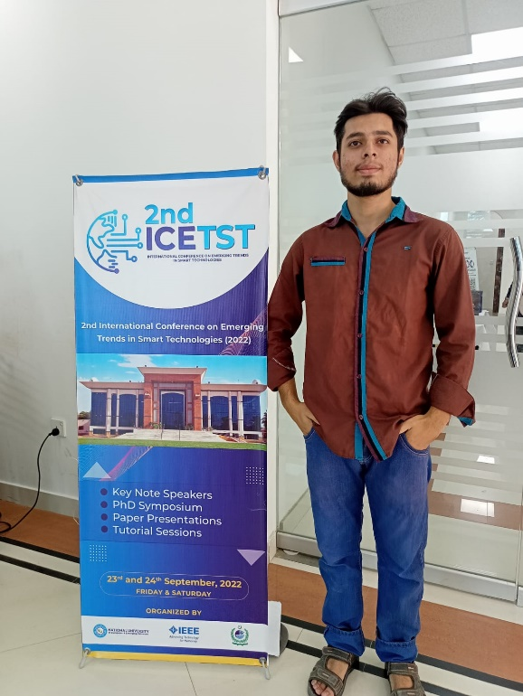

ABDUL SHAKOOR

19K-1373

FYP-ASSIGNMENT

ICETST CONTEST

## **MY ACTIVITIES:**

The ICE-TST contest occurs at FAST national university. As a Final year student, I have assigned the task to participate In the event and make a detailed report. The session I take in the auditorium are as follow:

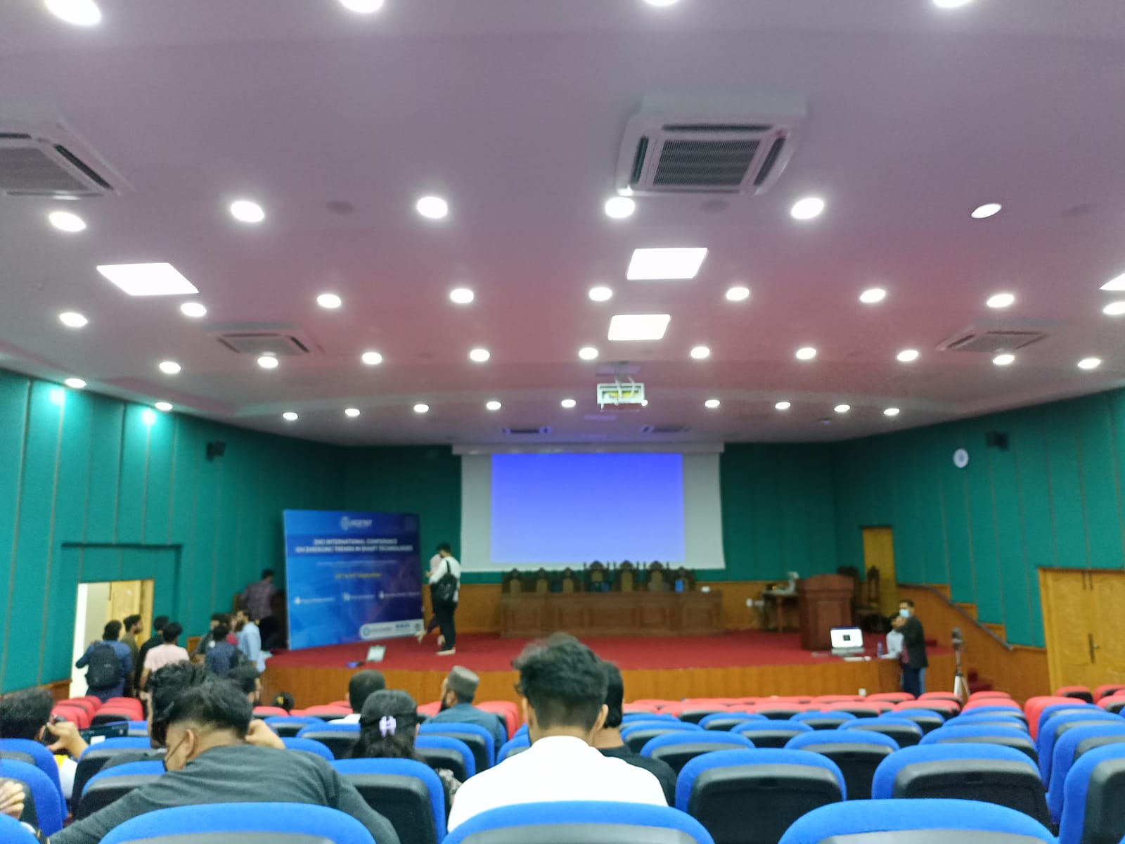

**RESEARCH PAPER STUDIED:**

1. Dynamic encounter of Zero-day multi-class cyber-attacks in IIOT
2. Investigation of Cisplatin hypersensitivity to testicular germs cell tumor using computing techniques.
3. 5G communication detection using a Bit.
4. Salad activity recognition using convolution neural network.

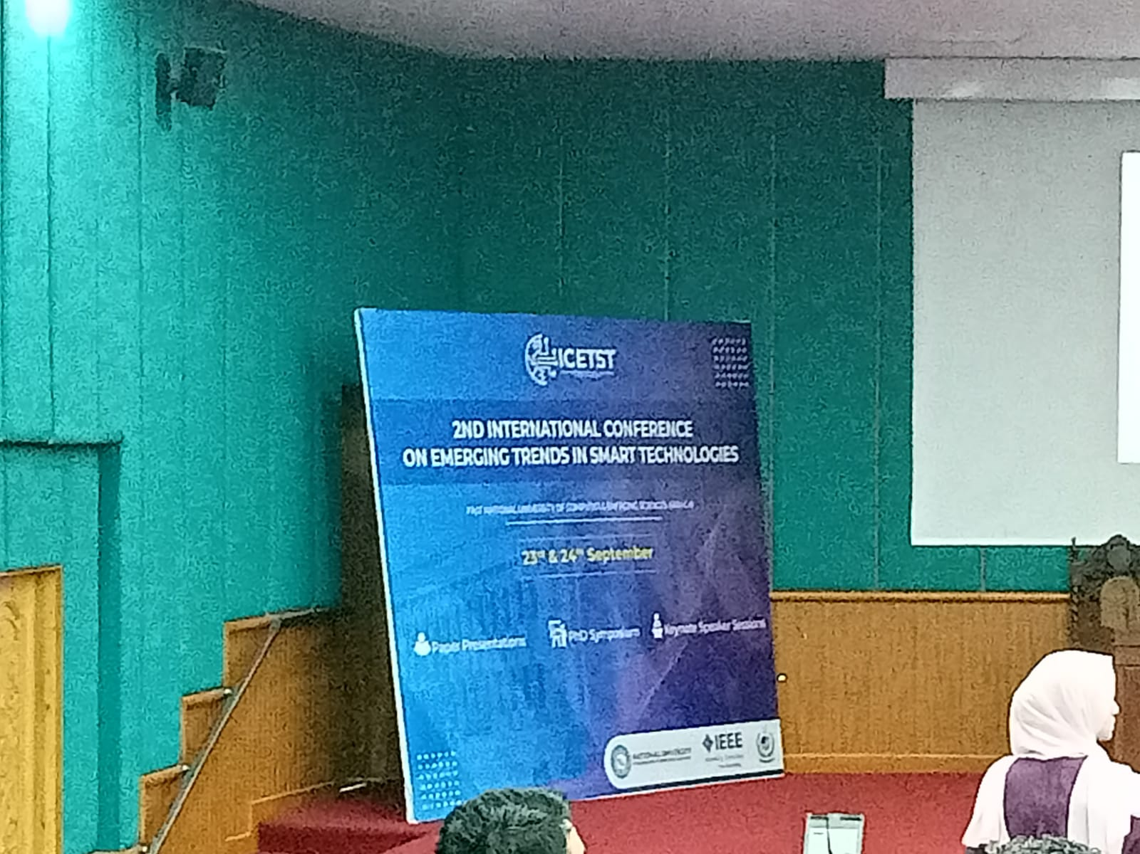

1. **Dynamic encounter of Zero-day multi-class cyber-attacks in IIOT:**

The author of this paper was Misbah Anwar. She explains the Network Traffic with the direction of attack. And how early patches can be recognized. The method she implemented is Federated Learning, collaborative learning, and a hybrid of both of them as well. She explains how to get and identify vulnerabilities by early detection and how to recover as soon as possible. The paper explained the Significance of IIT in several parts. For instance, ensuring safety and flexibility, etc.

IoT is an emerging technology, but the security of its devices and systems is a major concern. Therefore, this paper presented security concerns on IoT networks. Moreover, supervised, semi-supervised, and unsupervised machine learning methods were discussed for the detection of different malicious attacks in IoT networks.

In conclusion, The purpose of the paper is to make secure IIOT-based systems because they travel large amounts of data so if there Is any loophole. Immediate recovery patches should be there.

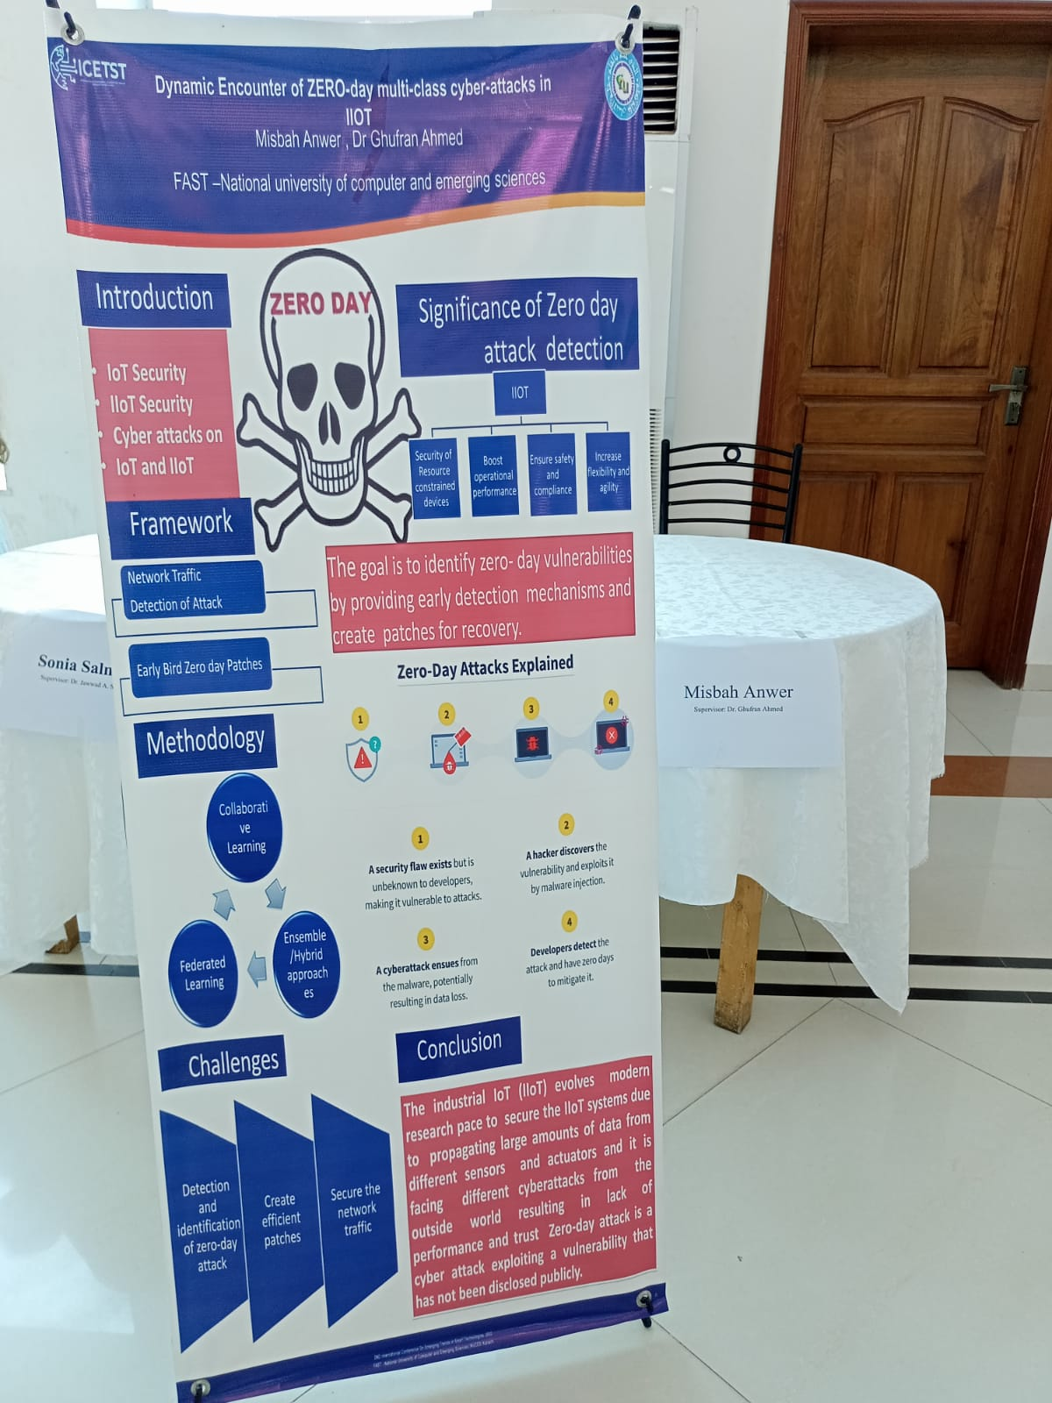

1. **Investigation of Cisplatin hypersensitivity to testicular germs cell tumor using computing techniques.**

The paper was proposed by Dr.Mehwish Wahid khan. As we know that cancer is a most complex disease and the big hurdle to diagnosing cancer is chemotherapy. Is there any replacement at the point she claims that molecular subtyping can contribute to this therapy?

The outdated subtyping is IGCT which does not provide good results. But molecular subtyping can be a great replacement. She uses deep learning to identify the results. The methodology used is a large amount of data processed through thousands of hidden layers and analyzed in the molecular subtyping samples. The results observed are a correlation between cells and p53 gene alteration.

In conclusion, IGCTs remain the only solid malignancy curable with chemotherapy. A greater understanding of the hypersensitivity and resistance of TGCTs has the potential to not only impact refractory patients but also may inform strategies to sensitize other solid tumors to conventional chemotherapies.

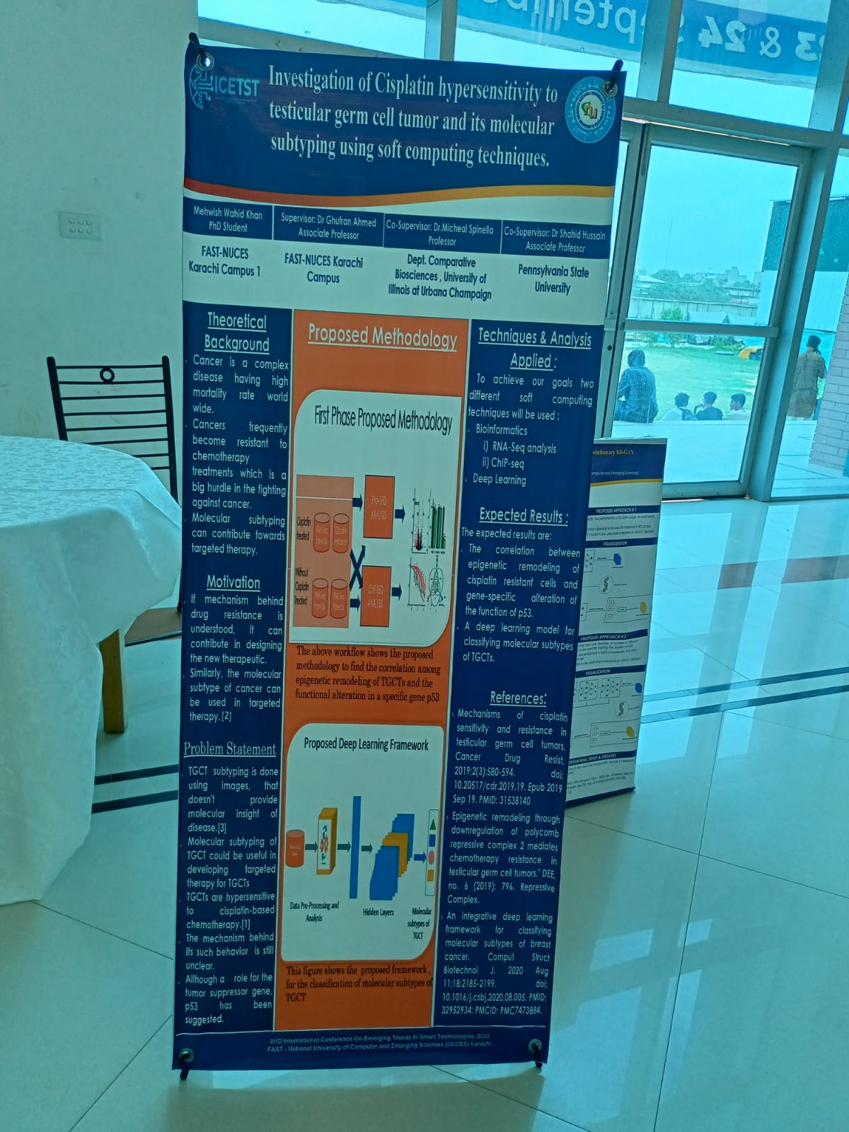

1. **5G communication detection using a Bit**

In this paper, The author explained MIMO are considered as the most important technology to attain the high data rate for next-generation mobile communication. It comprises more than one antenna at the sender and recipient sides. The detection of the signal in these systems is complex. In this work, we suggest a novel QRM-MLD algorithm with maximum likelihood detection to reduce the latency and complexity of the massive MIMO system. The simulation results indicate that the proposed system accomplished a reduced latency and complexity with a trivial penalty of bit error rate performance as compared to the existing techniques.

Massive multiple-input multiple-output (MIMO) is a backbone technology in the fifth-generation (5G) and beyond 5G (B5G) networks. It enhances performance gain, energy efficiency, and spectral efficiency. Unfortunately, a massive number of antennas need sophisticated processing to detect the transmitted signal. Although a detector based on the maximum likelihood (ML) is optimal, it incurs a high computational complexity, and hence, it is not hardware-friendly. In addition, conventional linear detectors, such as the minimum mean square error (MMSE), include a matrix inversion, which causes a high computational complexity. As an alternative solution, approximate message passing (AMP) algorithm is proposed for data detection in massive MIMO uplink (UL) detectors.

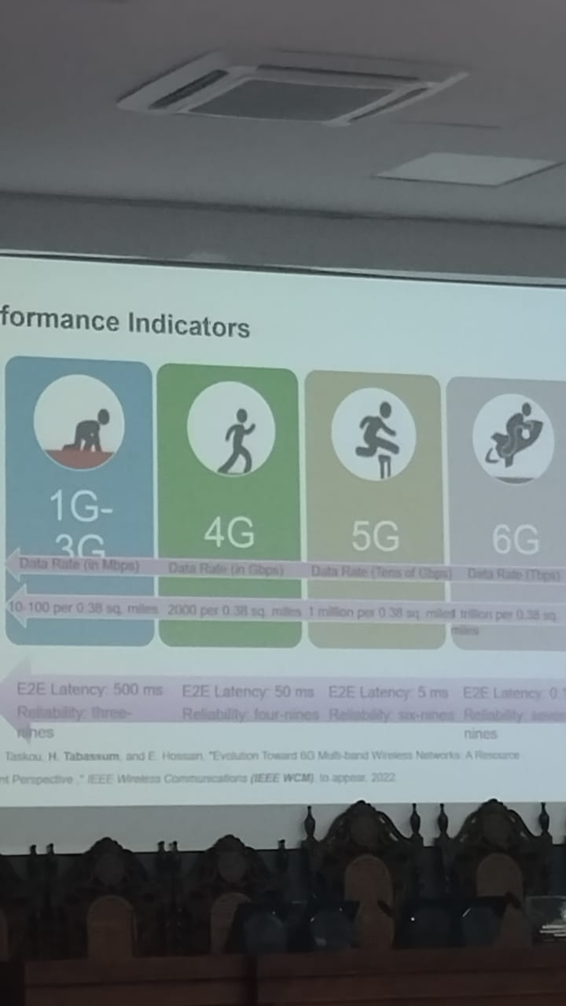

1. **Salad activity recognition using convolution neural network.**

In this paper, the author explained CNN. The CNN is the network that applies to images in which the image is processed multiple times through padding and filter. the basis of smart assistive technologies and manual processes analysis. Recently, deep neural networks have been deployed for HAR in the context of activities of daily living using multichannel time series. These time series are acquired from body-worn devices, which are composed of different types of sensors. The deep architectures process these measurements for finding basic and complex features in human corporal movements, and for classifying them into a set of human actions.

The proposed solution is that CNN-IMU’s accuracies and weighted F1 on the Opportunity-Gestures and Pamap2 datasets are superior with respect to the other architectures and the benchmarking. The classification accuracies of the CNN-IMUs on the Opportunity-gestures a significantly and better in comparison with the baseline CNN.

